Pre-Algebra - Chapter 4
Graphing & Writing Linear Equations

We will be doing this Chapter using a flipped classroom model. At home, you will be required to watch a video to complete your notes. In class the next day, we will work on the assignment for the section. To find the videos, use the QR code below or go to trumanmath8.weebly.com, find the Pre-Algebra page and click on the appropriate chapter.

Name __________________________________
Hour _________

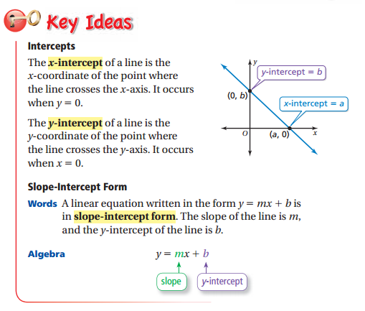
4.4 - Graphing Linear Equations in Slope-Intercept Form

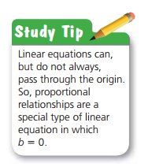

Example 1: Identifying Slopes and y-Intercepts
Find the slope and the y-intercept of the graph of each linear equation.
- $y=-4x-2 2. y-5=\frac{3}{2}x$

- y = x + 4 4. y = 3x

On Your Own: Find the slope and the y-intercept of the graph of the linear equation.
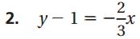
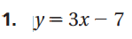

Example 2: Graphing a Linear Equation in Slope-Intercept Form
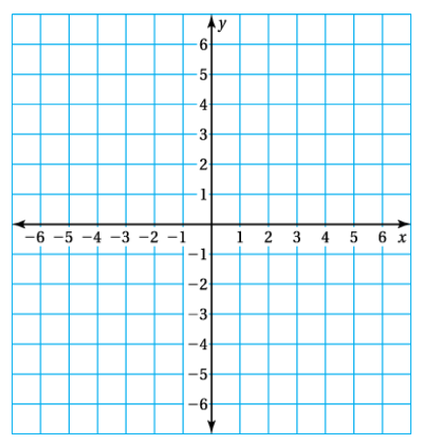
Graph y = −3x + 3. Identify the x-intercept.
Step 1: Find the slope and the y-intercept.
m = ______ b = ______
Step 2: Plot the y-intercept
Step 3: Use the slope to find other points and draw a line.
Step 4: Locate the x-intercept.

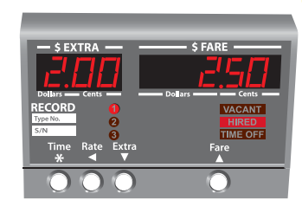
Example 3: Real Life Application
The cost y (in dollars) of taking a taxi x miles is y = 2.5x + 2.
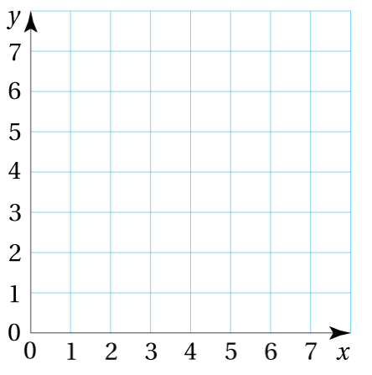
(a) Graph the equation.

(b) Interpret the y-intercept and the slope.

On Your Own: Graph the linear equation. Identify the x-intercept.
3. $y=x-4$

m = ______

b = ______

x-int: ______

4. $y=-\frac{1}{2}x+1$

m = ______

b = ______

x-int: ______

5. In Example 3, the cost y (in dollars) of taking a different taxi x miles is y = 2x + 1.5. Interpret the y-intercept and the slope.

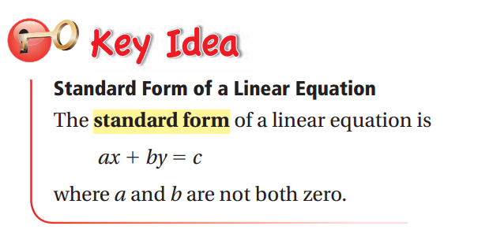
4.5 - Graphing Linear Equations in Standard Form – Part 1

Graphing a Linear Equation in Standard Form
Step 1: Change the equation from standard form to slope-intercept form (y = mx + b).
Step 2: Use the slope and the y-intercept to graph the equation.
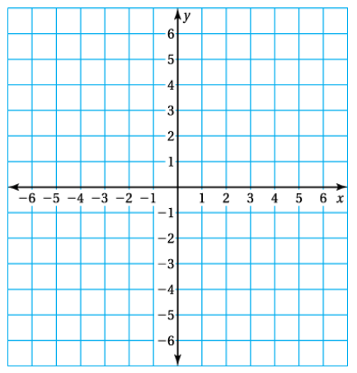
Example 1: Graph −2x + 3y = −6

On Your Own: Graph the linear equation. Follow the steps above.
- $x + y = -2$
- $-2y+2x=6$
- $-\frac{2}{3}x+y=0$
- $2x + y = 5$

4.5 - Graphing Linear Equations in Standard Form – Part 2

y-Intercept (b): The place where a line crosses the y-axis.
x-Intercept: The place where a line crosses the x-axis.

Determine the x and y intercept of each of the following:
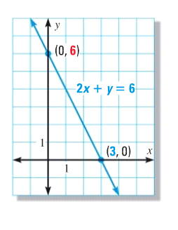
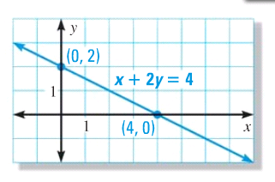

x-intercept = _____ x-intercept = ____

y-intercept = _____ y-intercept = _____

Graphing a Linear Equation in Standard Form – Using Intercepts
Step 1: To find the x-intercept, substitute 0 in for y.
To find the y intercept, substitute 0 in for x.
Step 2: Graph the equation.

Example 2: Graph $x + 3y = -3$ using intercepts.
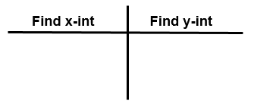

x-int: ________ y-int: ________

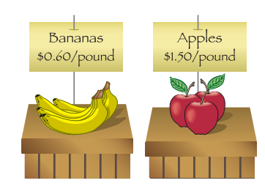
Example 3: Real Life Application
You have $6 to spend on apples and bananas.

(a) Graph the equation 1.5x + 0.6y = 6,
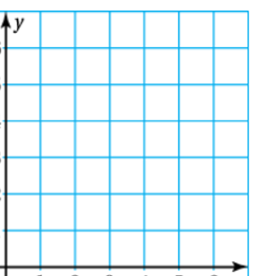
where x is the number of pounds of apples
and y is the number of pounds of bananas.
.

(b) Interpret the intercepts.

On Your Own: Graph the linear equation using intercepts.
5. $2x - y = 8$ 6. $x + 3y = 6$

4.6 - Writing Equations in Slope-Intercept Form

_{Example} 1: Write an equation of the line in slope-intercept form
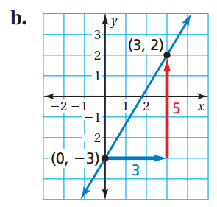
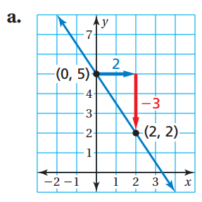

On Your Own:
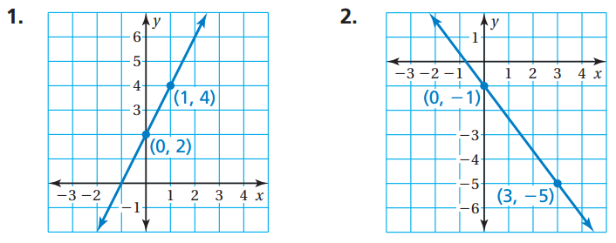

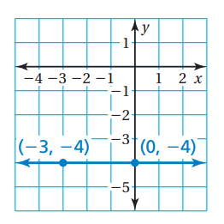
Example 2: Writing an Equation
Which equation is shown in the graph?

Example 3: Real-Life Application
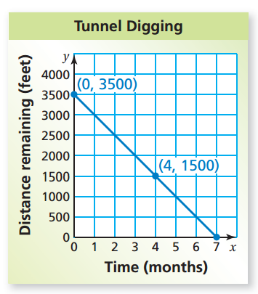
The graph below shows the distance remaining to complete a tunnel.
(a) Write an equation that represents the distance y (in feet) remaining after x months.
(b) How much time does it take to complete the tunnel?

On Your Own: Write an equation in slope intercept form for the line that passes through the points (0, 5) and (4, 5). Find the slope and y-intercept first.

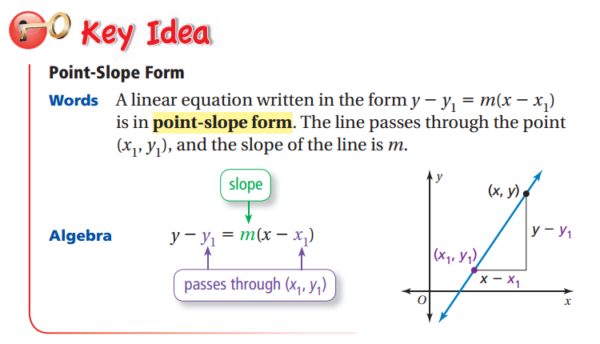
4.7 – Writing Equations in Point-Slope Form

Example 1: Writing an Equation Using a Slope and a Point
Write in point-slope form an equation of the line that passes through the point (−6, 1) with slope $\frac{2}{3}$.

On Your Own: Write in point-slope form an equation of the line that passes through the given point and has the given slope.

Example 2: Writing an Equation Using Two Points
Write in slope-intercept form an equation of the line that passes through the points (2, 4) and (5, −2).

On Your Own: Write in slope-intercept form an equation of the line that passes through the given points.
4. ( – 2, 1), ( 3, – 4) 5. (– 5, – 5), (–3, 3)

