Pre-Algebra - Chapter 4
Graphing & Writing Linear Equations

We will be doing this Chapter using a flipped classroom model. At home, you will be required to watch a video to complete your notes. In class the next day, we will work on the assignment for the section. To find the videos, use the QR code below or go to trumanmath8.weebly.com, find the Pre-Algebra page and click on the appropriate chapter.

Chapter 4 Assignments:
4.1: p146 #1,2,3-17odd,18-19,24,25,28-32

4.2 –day 1- Journal p. 76 & WS
4.2 –day 2- p153 #13-25,31,34,37-40

4.3: p162 #1-10,12,17

QUIZ – 4.1 to 4.3

Name __________________________________
Hour ________

4.1 – Graphing Linear Equations
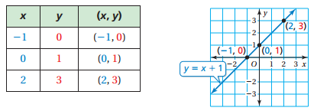
Vocabulary: A _______________________________ is an equation whose graph is a line. The points on the line are _________________________ of the equation. You can use a graph to show the solutions of a linear equation. The graph below represents the equation y = x + 1.

Graphing Linear Equations
Step 1: Make a table of values
Step 2: Plot the ordered pairs
Step 3: Draw a line through the points

Example 1: Graph $y=-2x+1$.
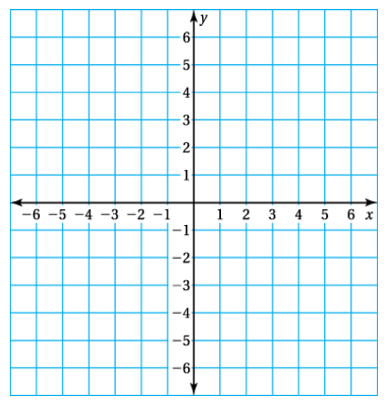
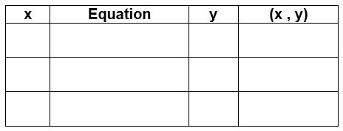

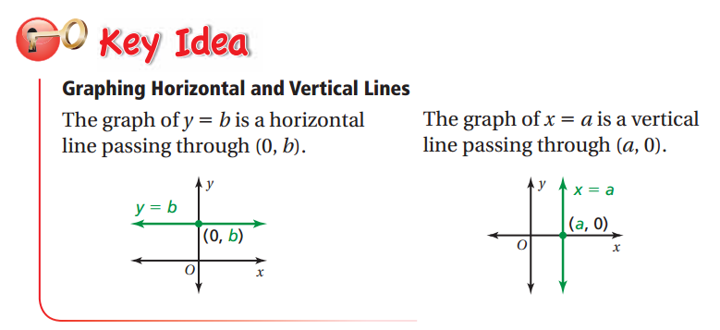

Example 2: Graphing Horizontal and Vertical Lines
- Graph y = − 3 b. Graph x = 2

On Your Own: Graph the linear equations.
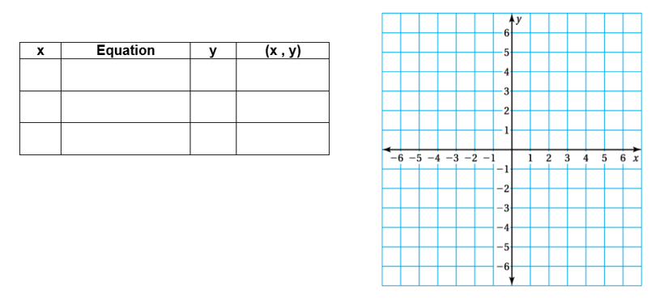
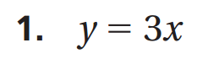
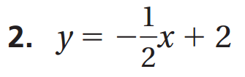

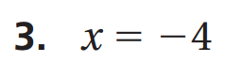

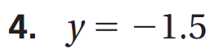

Example 3: Real Life Application
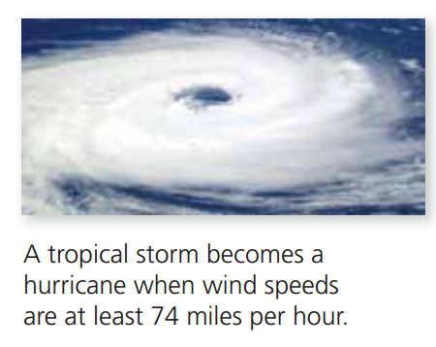
The wind speed y (in miles per hour) of a tropical storm is y = 2x + 66, where x is the number of hours after the storm enters the Gulf of Mexico.
a. Graph the equation.
b. When does the storm become a hurricane?

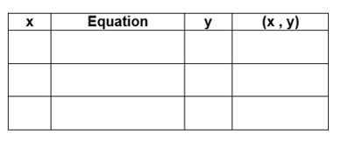

4.2 Slope of a Line

Vocabulary: The _______________________ “m” of a line is a ratio of the change in y to the change in x between any two points: (x₁, y₁) and (x₂, y₂), on the line.
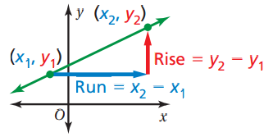

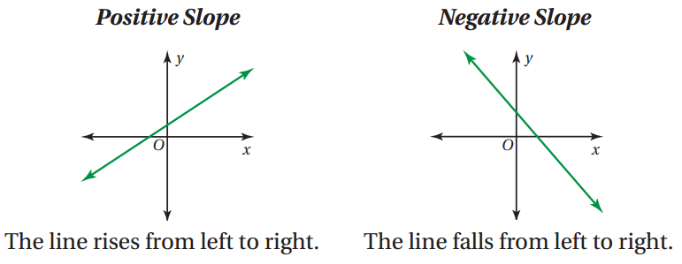

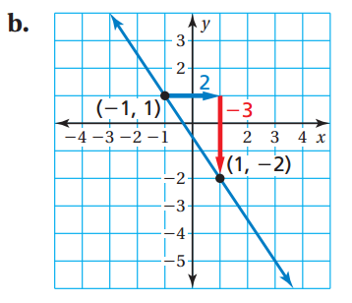
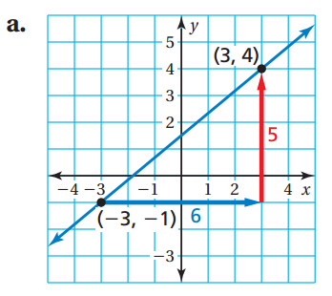
Example 1: Describe the slope of the line. Then find the slope.

On Your Own
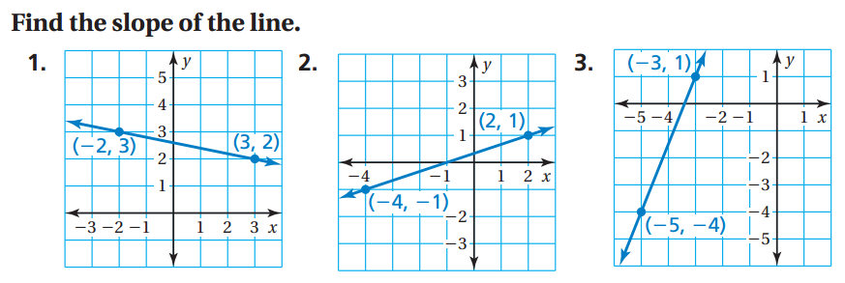

Example 2: Horizontal Lines
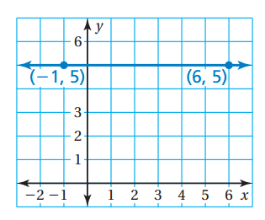
Find the slope of the horizontal line.
Example 3: Vertical Lines
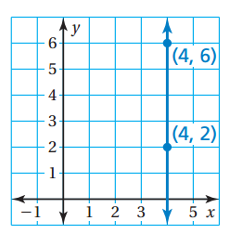
Find the slope of the vertical line.

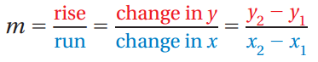
4.2 Part 2:

Example 2: Horizontal Lines
Find the slope of the horizontal line.
Example 3: Vertical Lines
Find the slope of the vertical line.

On Your Own: Find the slope of the line through the given points.
4. (1, −2), (5, 6) 5. (−2, 4), (3, 10)

Example 4: Finding Slope from a Table
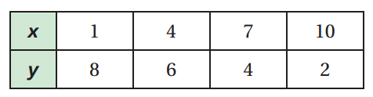
The points in the table lie on a line. How can you find the slope of the line from the table? What is the slope?

Slope Formula: $m= \frac{Δy}{Δx}$

On Your Own: The points in the table lie on a line. Find the slope of the line.

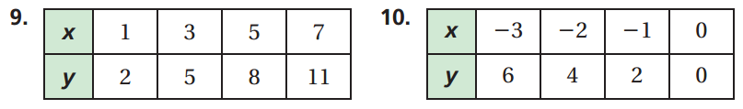

What would slope dude say for each of these? If needed, go back to trumanmath8.weebly.com and watch the Slope Dude Video.
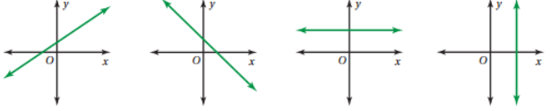

What other video is there to help you?
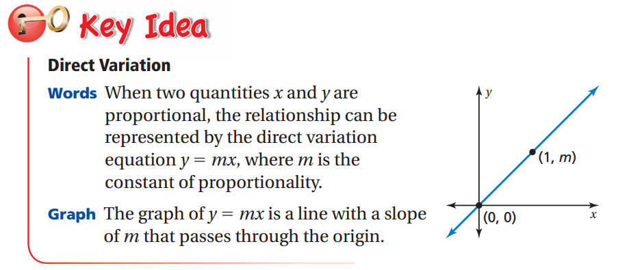
4.3 – Graphing Proportional Relationships

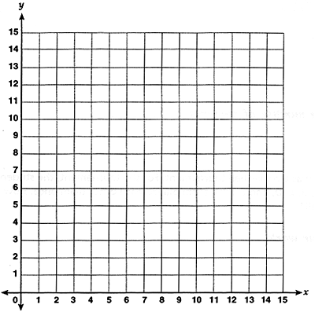
Example 1: Graphing a Proportional Relationship
The cost y (in dollars) for x gigabytes of data on an Internet plan is represented by y = 10x. Graph the equation and interpret the slope.
Example 2: Writing and Using a Direct Variation Equation
The weight y of an object on Titan, one of Saturn’s moons, is proportional to the weight x of the object on Earth. An object that weighs 105 pounds on Earth would weigh 15 pounds on Titan.
- Write an equation that represents the situation.

- How much would a chunk of ice that weighs 3.5 pounds on Titan weigh on Earth?

Example 3: Comparing Proportional Relationships
The distance y (in meters) that a four-person ski lift travels in x seconds is represented by the equation y = 2.5x. The graph shows the distance that a two-person ski lift travels.
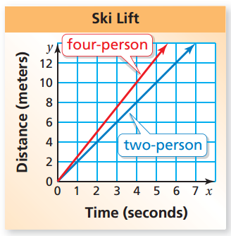
- Which ski lift is faster?
- What does the steepness of the slope have to do with the context of the problem?

On Your Own: The table shows the distance y (in meters) that a T-bar ski lift travels in x seconds. Compare its speed to the ski lifts in Example 3.
